Git Assignment

Create a local git repository

Commit the initial code

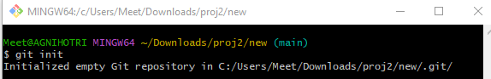

Update the code on the remote server . Also perform some changes on remote n

reflect the same on local.

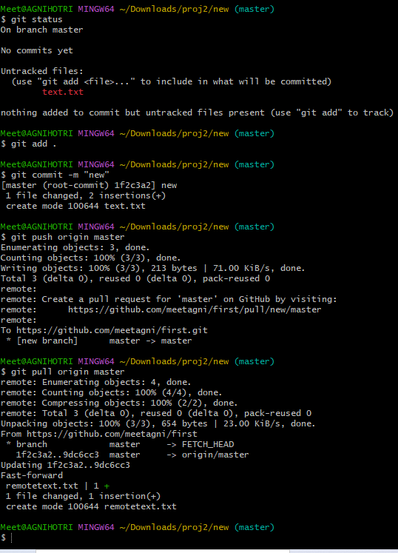

Raise a pull request on remote and merge without conflicts.

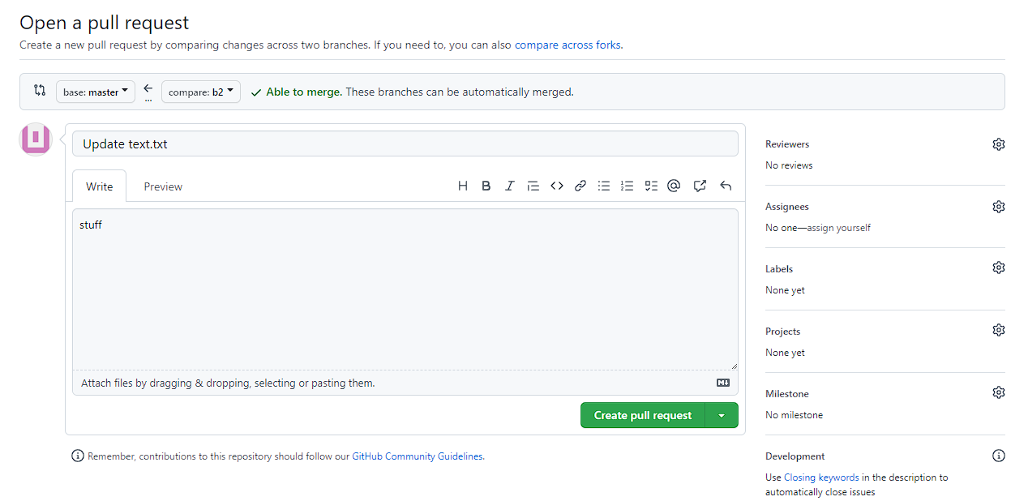

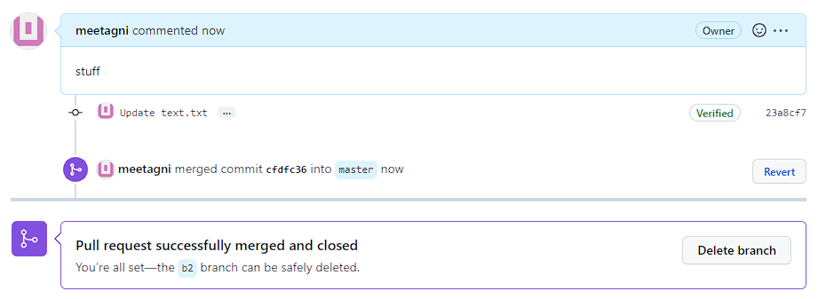

Use git commands to

o Get the updated files

o Perform reset

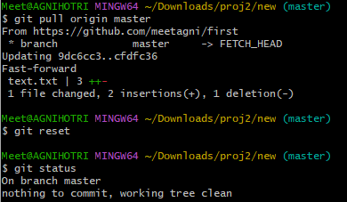

o List the changes

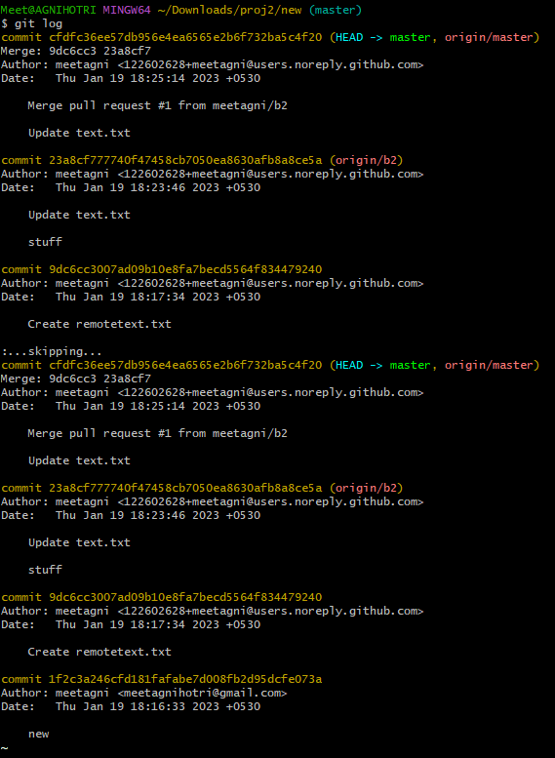

o Create branches b1,b2,b3 and update them as well.

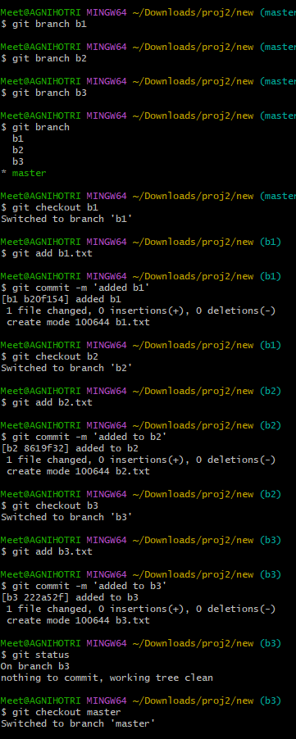

o List the changes

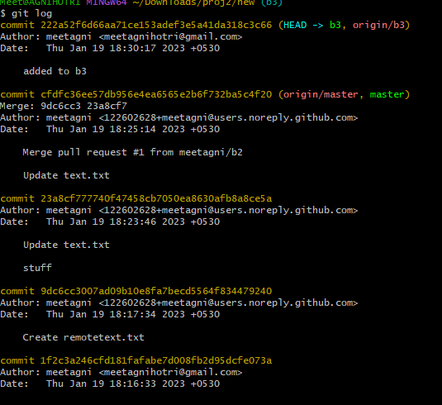

Demonstrate diff between branches

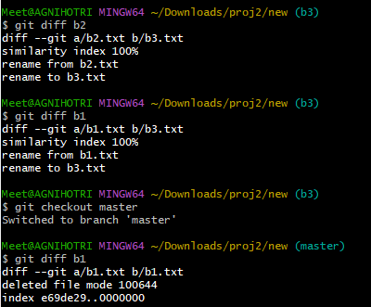

Perform merging operation and after that delete the unnecessary ones locally as

well as remote

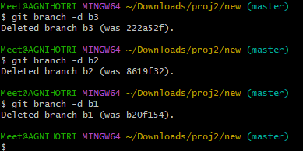

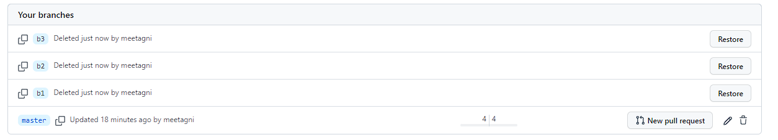

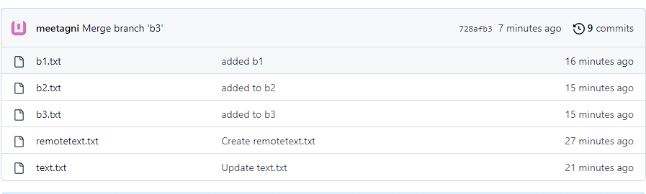

Perform fork operations on your repository as well.

